Створив Когут Богдан

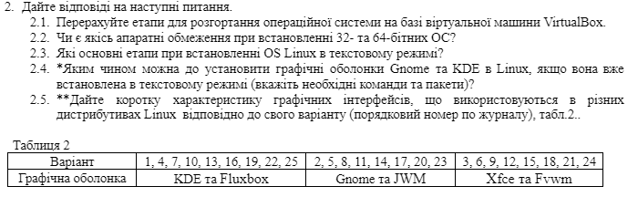

2. Answer the following questions:

2.1. List the steps for deploying an operating system based on a VirtualBox virtual machine.

2.2. Are there any hardware limitations when installing 32-bit and 64-bit operating systems?

2.3. What are the main steps for installing a Linux OS in text mode?

2.4. How can you install the Gnome and KDE graphical shells in Linux if it has already been installed in text mode (specify the necessary commands and packages)?

2.5. Provide a brief description of the graphical interfaces used in different Linux distributions according to your variant (refer to Table 2).

**2.1. Steps for deploying an OS based on VirtualBox:**

1. Install VirtualBox: Download and install VirtualBox on your host machine.

2. Create a New Virtual Machine (VM): Open VirtualBox and click "New" to create a new virtual machine. Set the name, type of OS, and version (32-bit or 64-bit).

3. Allocate Memory (RAM): Choose the amount of RAM for the virtual machine, typically between 1 to 2 GB for lightweight Linux distributions.

4. Create Virtual Hard Disk: Select the option to create a new virtual hard disk and choose the size (e.g., 20 GB or more depending on the OS).

5. Select the Installation ISO: Under the "Storage" section, choose the ISO file for the OS installation.

6. Start the VM: Start the VM, and the OS installation will begin from the selected ISO.

**2.2. Hardware limitations when installing 32-bit and 64-bit OS:**

- 32-bit OS: Can only use up to 4 GB of RAM. It is recommended for older hardware or processors that don't support 64-bit.

- 64-bit OS: Requires a 64-bit processor and allows for more than 4 GB of RAM. Modern hardware generally supports 64-bit, making it the standard choice for most installations.

**2.3. Main steps for installing Linux OS in text mode:**

Start from installation media: Boot from a CD or USB where your Linux installer is stored.

Choose text mode installation: Select the text-based installation option.

Set up disk partitions: Use tools like fdisk to create partitions on your hard drive.

Install the basic system: Download and install the core packages needed to run Linux.

Install a bootloader: Add a program like GRUB so your system can boot properly.

Set up network: Configure network settings either by editing files or using simple text-based tools.

Reboot: After installation, restart your system and log in.

**2.4. How to install Gnome and KDE if Linux is in text mode:**

**For Gnome:**

1. Update your package manager:

sudo apt update

2. Install Gnome:

sudo apt install gnome-shell

3. Start Gnome with this command:

sudo systemctl start gdm3

4. Set Gnome to start automatically:

sudo systemctl enable gdm3

**For KDE:**

1. Install KDE:

sudo apt install kde-plasma-desktop

2. Start KDE’s display manager:

sudo systemctl start sddm

3. Set KDE to start automatically:

sudo systemctl enable sddm

**2.5. Brief description of graphical interfaces (for KDE and Fluxbox):**

**- KDE:**

- KDE is a powerful and feature-rich desktop environment. It’s highly customizable and offers a lot of advanced settings, making it great for users who want more control over their system’s appearance and behavior. KDE comes with a full suite of applications like file managers, text editors, and system settings tools. It is known for being visually appealing while still performing well on modern systems.

**- Fluxbox:**

- Fluxbox is a lightweight window manager that focuses on speed and simplicity. Unlike KDE, it doesn’t come with a lot of built-in apps or features. Instead, it provides a minimalistic environment where users can open windows and manage tasks efficiently. It’s great for older hardware or when you want a clean, fast interface without extra features.